[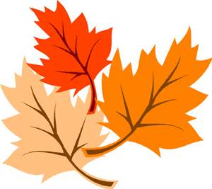](http://www.bing.com/images/search?q=fall+leaves&view=detailv2&&id=7B793368232486FDA5D1BC811071721ADF0F1CB7&selectedIndex=0&ccid=e0IY9ONV&simid=607995970600374181&thid=OIP.M7b4218f4e3557b0279a2c05f7af69449H0)**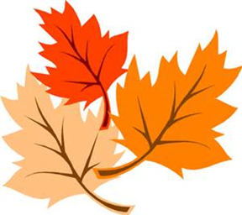TRIO SSS**

[](http://www.google.com/url?sa=i&rct=j&q=&esrc=s&frm=1&source=images&cd=&cad=rja&uact=8&ved=0CAcQjRxqFQoTCLeX0b2AvsgCFY08iAodwuYCNw&url=http://crownpointlibrary.org/Books,-Movies-&-Music.html&psig=AFQjCNHTHqA3m3Pl36Dki8xKD4byONrryA&ust=1444776087248438)**FALL TERM STUDY SESSION**

**December 04**

**Waldo 400**

**5:00 – 8:00 PM**