The combined EOP, TRIO SSS, CAMP, and LSAMP Programs
are having a party to celebrate
all of the students who demonstrated academic excellence

Fall Term 2018

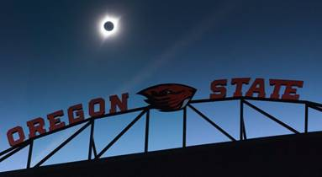

What: Honor Roll Celebration

When: Thursday, January 31, 2019

Where: Waldo Hall Room 348

Time: 11:00 am to 1:00 pm

(Drop in when you can – no need to stay the entire time)

Please come by to enjoy cake/snacks and help us celebrate the achievements of all the great students in our programs!

This term’s Celebration is hosted by the TRIO SSS Program.

