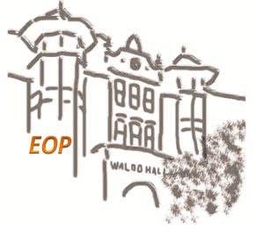
Tutoring
Drop in & by Appointment!

MONDAY | TUESDAY | WEDNESDAY |  | THURSDAY | WRITING CENTER
Centro Cultural César Chávez  5:00 – 9:00 PM  ENGR 201, 211, 213, 391  PH 201, 202, 211, 212, 213  MTH 102, 103, 111, 112, 251, 252  5:00 – 9:00 PM  CH All 100-level, 231, 232, 233, 331, 332, 337  BI All 100 and 200-level, 311, 314  BB 450, 451  PH 203 | Native American Longhouse, Eena Haws  5:00-8:00 PM  HDFS 107, 201, 240, 311, 313  NUTR 225, 312  PSY 201, 202  SPAN 314, 315, 316, 327  WGGS 270, 280  WR 121, 327  ART 110  7:00 – 9:00 PM  ENGR 211  PH 201, 202, 211, 212  MTH 102, 103, 111, 112, 251, 252 |  | Lonnie B. Harris Black Cultural Center  5:00 – 9:00 PM  ENGR 201, 211, 213, 391  PH 201, 202, 211, 212, 213  MTH 102, 103, 111, 112, 251, 252 | Asian & Pacific Cultural Center  5:00-8:00 PM  HDFS 107, 201, 240, 311, 313  NUTR 225, 312  PSY 201, 202  SPAN 314, 315, 316, 327  WGGS 270, 280  WR 121, 327  ART 110  5:00 – 9:00 PM  CH All 100 and 200-level, 331, 332, 337  BI All 100-level, 231, 232, 233, 311, 314  BB 450, 451  PH 203 | CCCC, NAL, LBHBCC, APCC  Regular hours for Writing Assistance will be available soon. Until then, please request appointments via Writing Center Website.  http://writingcenter.oregonstate.edu/making-appointment

